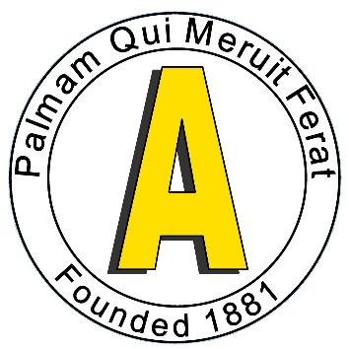
Anerley Bicycle Club
Open 10 Mile Time Trial – Results
Saturday 11th May 2024 Course G10/42
Promoted for and on behalf of Cycling Time Trials under their rules and regulations.

Timekeepers: Richard Meed and Chris Woods
Anerley BC Event team:
Overall Coordinator: Peter Roberts
Event Secretary: Mark Hancock
HQ Team: Meike Turnbull, Ginny Hancock, Marilyn Course, Dave Stott, Gerry Upson.
Marshalls & Pushers Frank Kippin, Bob Gilly, Jim Kenison, Su Diamond, Barrie Foster, Graham Dixon, Tom Moody, John Dadson, John Eden
Finish Tom Vaz, Asif Iqbal.

First of all a big thank you to our event team and the Timekeepers, without them we could not have run this TT. Second, thanks to all the riders who entered, and helped make this a successful event.

The weather was good and there were no issues with the course. There were perhaps slightly higher traffic levels due to the M25 closure but we compensated for this by additional event signs to raise drivers’ awareness. There was one near miss, caused by a driver travelling the WRONG way round Clarkes Green roundabout, but that was not related to the event. Great awareness by the TT rider involved avoided an accident.

Time Trial Bikes:
First Fastest open Jacob Storey trainSharp 00:19:30
Second Fastest open Liam Maybank Twickenham CC 00:19:39
First fastest female Francine Davis East Grinstead CC 00:25:30
Second fastest female Domie Pollard East Grinstead CC 00:39:44

Road Bikes:
First fastest open Tony Reeves GS Stella 00:25:21
Second Fastest open Christopher Gatt VC de Londres 00:26:25
First fastest female Phoebe Perry trainSharp 00:28:18
Second fastest female Mona Chammas PDQ Cycle Coaching 00:30:23

Team Prize: Paul Burton, Ben Elliot and Pat Wright Paceline RT 01:02:10

Photographs: Paul Carpenter – paulcarpenter1992@hotmail.com

